# **Name: Abdurrahman Qureshi**

# **Roll No: 210451**

Practical No: 18

**1) Write a Program to create a Student Table in database and insert a record in a Student table.**

import java.sql.*;  
public class Main  
{  
 public static void main(String args[])  
 {  
 try  
 {  
 Class.*forName*("sun.jdbc.odbc.JdbcOdbcDriver");  
 Connection con=DriverManager.*getConnection*("jdbc:odbc:myAJPSource");  
 Statement st=con.createStatement();  
 st.executeUpdate("create table S_TABLE(RollNum int,S_NAME char)");  
 System.*out*.println("Table Created");  
  
 st.executeUpdate("insert into student values(1051,'qarq90')");  
 System.*out*.println(" 1 Row Inserted");  
  
 con.close();  
 }  
 catch(Exception e)  
 {  
 System.*out*.println(e.getMessage());  
 }}}

**OUTPUT:**

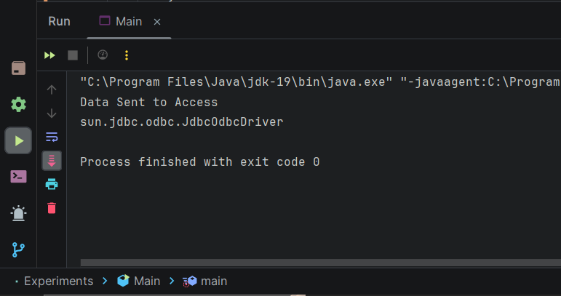

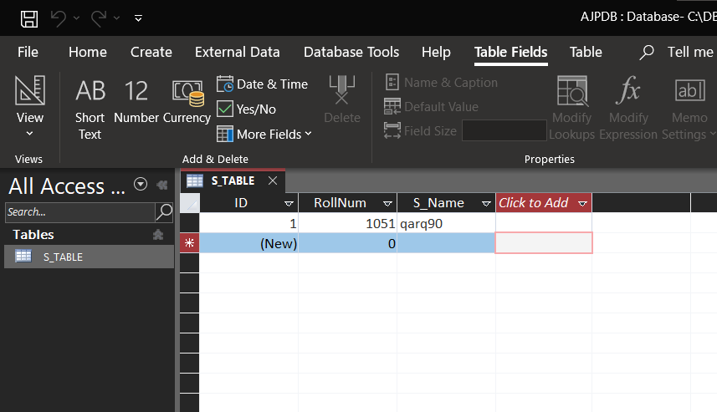

**2) Write the output of following code**

**CODE:**

import java.sql.*;

class Main{

public static void main (String args[]){

try{

Class.forName("sun.jdbc.odbc.JdbcOdbcDriver");

System.out. println(" Driver loaded");

String url= "jdbc:odbc:MSBTE";

Connection cn= DriverManager.getConnection(url);

System.out.println("Connection established");

Statement st= cn.createStatement();

String str= "select* from student";

ResultSet rs=st.executeQuery(str);

String text=" ";

System.out.println("Roll Number \t\tName");

while(rs.next()){

text= text+rs.getInt(1)+"\t\t\t"+rs.getString(2)+"\n";}

System.out.print(text);

st.close();

cn.close();}

catch (Exception s)

{System.out.println("sql error");}}}

**OUTPUT:**

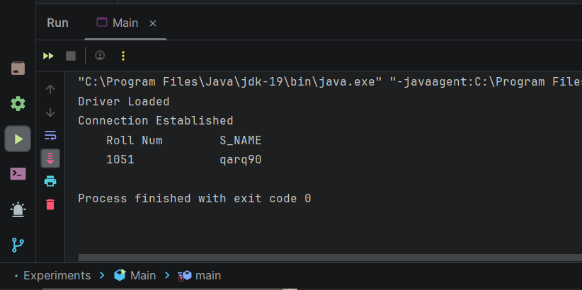

**3) Develop a program to create employee table in database having two columns “emp_id” and “emp_name”.**

**CODE:**

import java.sql.*;

public class Main{

public static void main(String args[])

{

try{

Class.forName("sun.jdbc.odbc.JdbcOdbcDriver");

Connection con=DriverManager.getConnection("jdbc:odbc:exp13");

Statement st=con.createStatement();

st.executeUpdate("create table employee(empid int,empname char)");

System.out.println("Table Created");

con.close();

}

catch(Exception e){

System.out.println(e.getMessage());

}

}

}

**OUTPUT:** 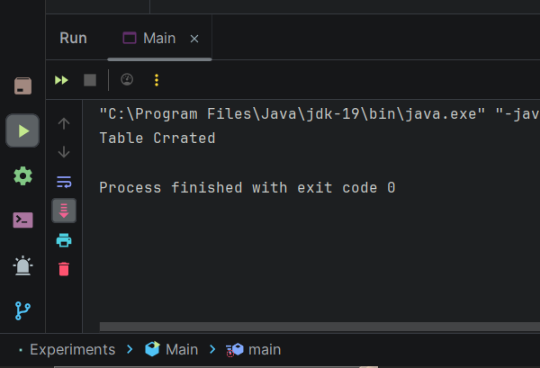

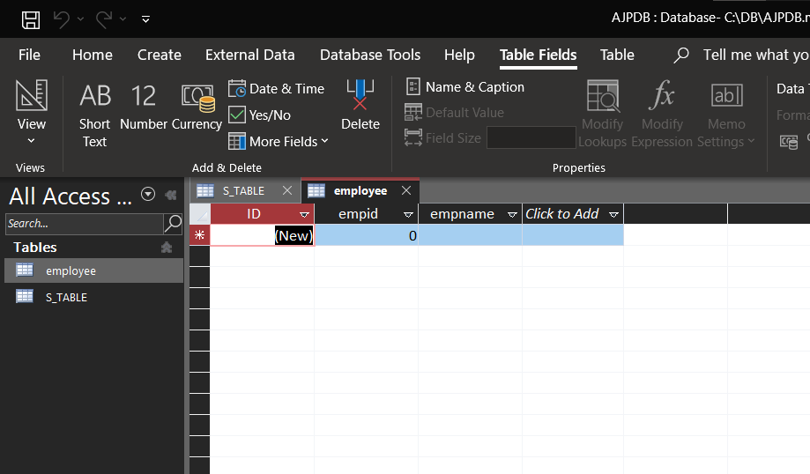

**4) Develop a program to display the name and roll_no of students from “student table” having percentage > 70.**

**CODE:**

import java.sql.*;  
public class Main  
{  
 public static void main(String args[])  
 {  
 try  
 {  
 Class.*forName*("sun.jdbc.odbc.JdbcOdbcDriver");  
 Connection con=DriverManager.*getConnection*("jdbc:odbc:exp13");  
 Statement st=con.createStatement();  
  
 ResultSet rs=st.executeQuery("Select * from Student where sper>70");  
  
 System.*out*.println("Students - Above 75% ");  
 System.*out*.println("rollno \tname");  
 while(rs.next())  
 {  
 System.*out*.println(rs.getInt(1)+"\t\t"+rs.nextLine(3));  
 }  
  
 con.close();  
 }  
 catch(Exception e)  
 {  
 System.*out*.println(e.getMessage());  
 }  
 }  
}

**OUTPUT:**

